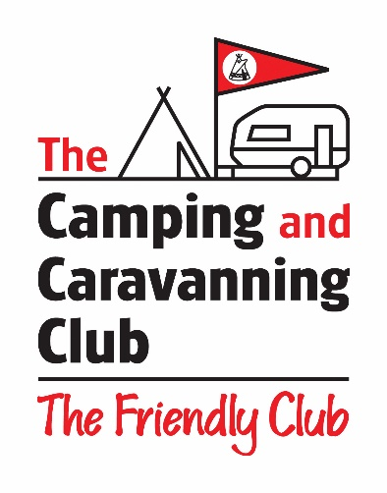

*****************COVID-19 BOOKING UPDATE*****************

While most of our Club Sites are open for business, due to COVID-19 there are some sites that are closed or operating with limited facilities. Please use our dedicated webpage to check out your intended Club Site before booking and to find out how we are keeping our sites safe for visitors.
https://www.campingandcaravanningclub.co.uk/helpandadvice/travelplanning/coronavirus/
As we are currently operating a contactless check-in, we are unable to process the Motorhome Hire Scheme discount on site as we usually would.
Instead, you will need to book your pitch over the phone with our cheerful and helpful Service Centre by calling 024 7647 5426. Please let the advisor know that you are booking under the Motorhome Hire Scheme so they can discount your pitch fees.
A minimal deposit is taken upon booking, and the balance will be automatically collected on the morning of the date of arrival on site.

